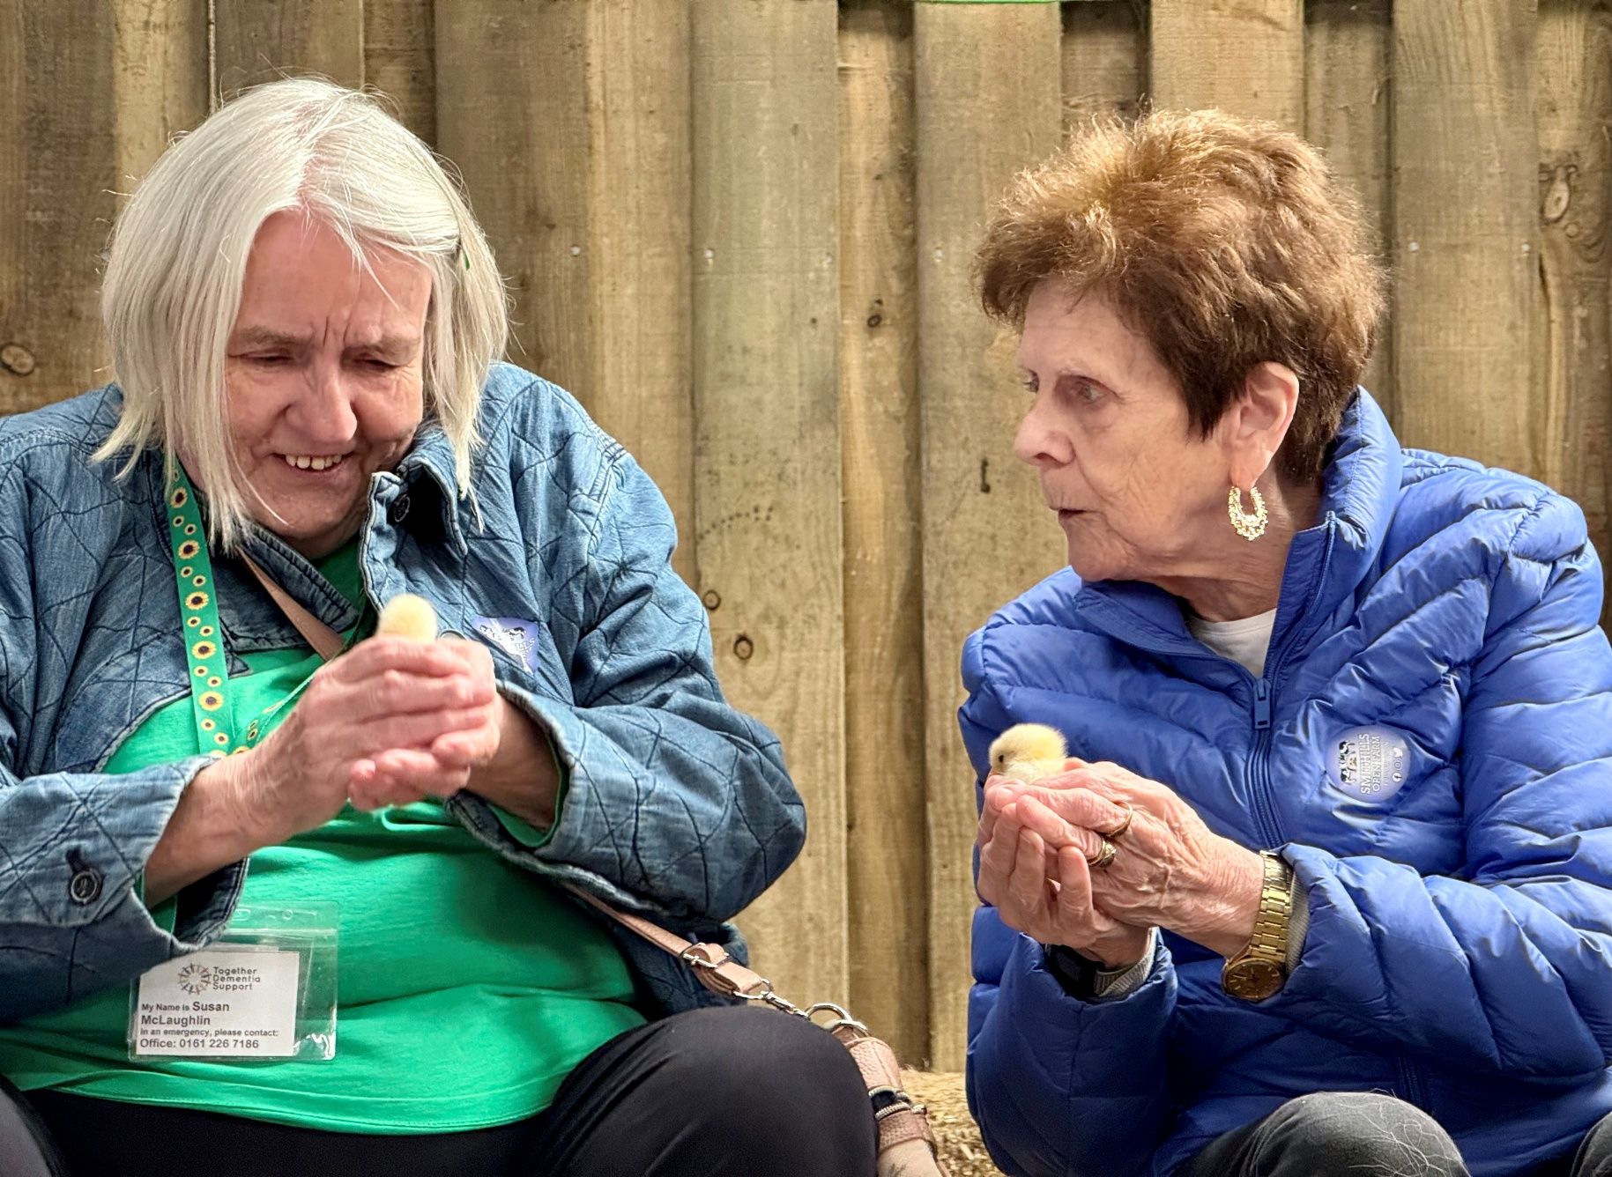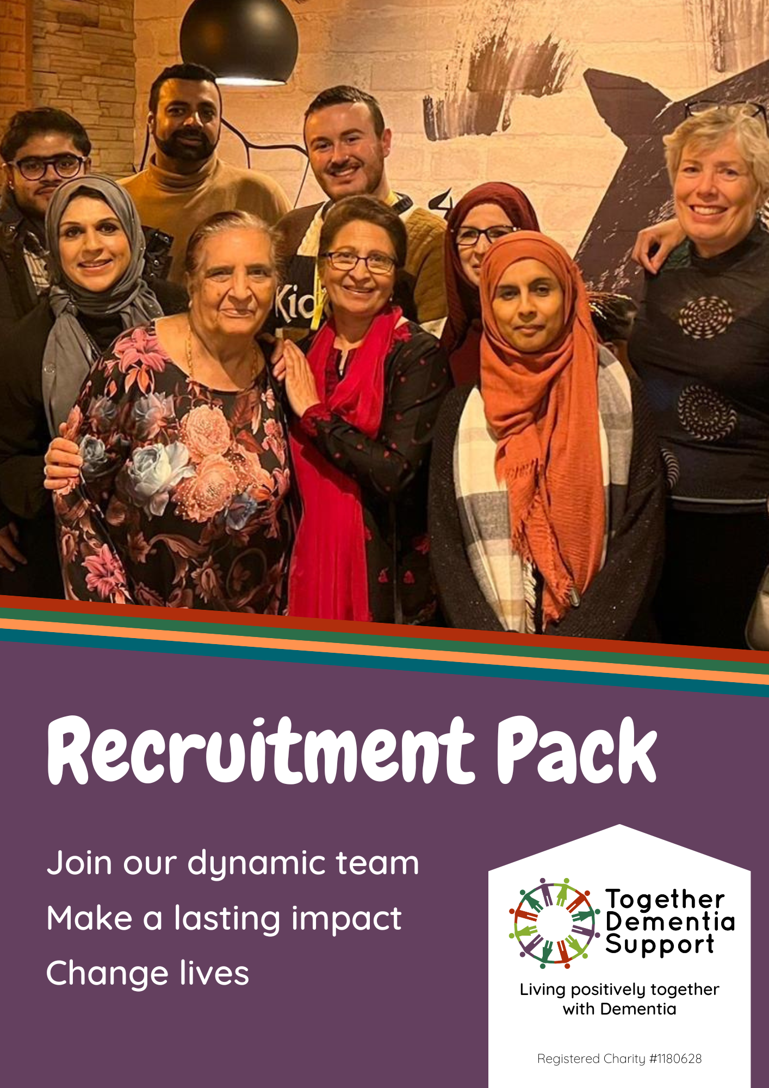

Welcome

## We are Together Dementia Support

Together Dementia Support was founded in 2014 by our CEO, Sally Ferris. Through her work experience in the dementia field, she saw the vacuum in support available to people after a diagnosis of dementia. She was shocked that people with the condition were left to decline, unsupported, at home and that no hope was given to either them or their families. There was no-one there to give information and emotional support, and there was certainly nowhere to go to see friends and enjoy activities and conversation.

Sally Ferris, CEO

BSc, MA, MSc Dementia Care

Sally decided to study for a master’s degree in Dementia Care at the University of Manchester, learning about evidence-based practice and how to lead change. She then felt that she had to put her learning into practice and create the sort of dementia community that would enable positive person-centred care and support for both the people living with dementia and their families. This is how Together Dementia support was born in 2014.

What started as a small Community Interest Company is now a thriving charity, with 11 FTE staff, 11 regular groups across Manchester and Trafford, and over 600 people regularly supported by the service. For people living with Dementia, we offer a range of activities such as social groups, walking groups, arts & crafts, music and games groups, as well as one-to-one at home social activity support. For carers, we provide online and in person group support, one-to-one advice and guidance, training opportunities, social outings, regular short-term respite and a friendly ear to listen.

What we do is unique, and the University of Salford conducted a study from 2019 – 2022 to assess the impact of our approach. They found, overwhelmingly, that people’s wellbeing significantly improved from our research and experience-based skill maintenance activities, positive social interaction, and positive and inclusive attitude to dementia. Our services could mean a person living with dementia is able to maintain functional skills for longer than they would have without our support.

Currently, it is estimated that over 5,000 people are living with dementia in Manchester alone but many of them are not getting regular support.

Join our team, help us reach more of the 5,000 people, and be the positive difference made in someone’s life.

There is no small role in our organisation, and everyone – from our minibus drivers and business support staff to our Dementia Support Co-ordinators– makes a difference with everything they do.

We hope you will be inspired by us, and see yourself as part of our friendly, thriving and dedicated team changing lives in Manchester and Trafford.

## Meet the Senior Leadership Team

|  |  |
| --- | --- |
|  | SALLY FERRIS BSc, MA, MSc Dementia Care **Founder & CEO**  Sally has worked with older people in the NHS, Social Services and voluntary sector for over 30 years. She chose to specialise in dementia support and has an MSc in Dementia Care. Sally loves the opportunities TDS has to have to offer innovative services that respond to local people’s needs – to make a real difference on the ground.  “**I look for people who have** **high standards and who are keen to learn and develop. We have an ethos of person-centred care, innovation, and commitment to our service users; our employees reflect this with everything they do.”** |

|  |  |
| --- | --- |
|  | MIKE GOVIER **Operations Manager**  Mike has recently joined the team as Operations & Data Manager. He has a background as an Electronics Engineer in the Flight Test Departments at British Aerospace. Mike worked in project management roles at various BAe Systems civil aircraft and military aircraft sites. Mike has then worked as a School Business Manager before becoming CFO for a Multi Academy Trust operating eight school sites alongside a teacher training SCITT.  **“TDS is a fabulous place to work where you can really make a difference and contribute skills in a way that you will find hugely rewarding. You will find a team of people with a great work ethic who strive hard to achieve the highest standards and outcomes for our members and carers”** |

|  |  |
| --- | --- |
|  | CLAIRE MARRETT **Service Delivery Manager**  Claire joined TDS in 2019, having worked in Salford for the previous ten years – supporting carers and people living Dementia for Age UK Salford. She also did engagement work with the Institute for Dementia at Salford University. She has a PGCert in Dementia and the Enabling Environment.  **“Excellent teamwork is one of the reasons TDS does what it does so well. I look for candidates who are dedicated to doing the best job they can for our clients, who support their colleagues and who are competent, kind, and strong communicators.”** |

## Benefits when working with TDS

Here at Together Dementia Support we are able to provide a competitive salary, plus extra benefits.

* Annual leave allowance increases in line with years of service.
* An attractive office space, with on-site cafe
* A staff discount scheme, covering popular brands such as Pandora, Look Fantastic, JD Williams, Argos, Boots and more. You can also save on your holidays with Ho Seasons, Cottages UK, TUI and others.
* Generous sick leave arrangements, increasing incrementally with years of service and supported by our Employee Assistance Programme. The programme also includes access to free counselling other well-being assistance tools.
* Ongoing professional development opportunities
* Regular wellbeing and team outings and activities
* Flexible working arrangements, depending on job role
* Free onsite parking at our main office

“Working with Together Dementia Support is so fulfilling. You get so much out of it, meet some amazing people, and you see week in week out the difference you are making to people's lives.”

~ Beth Langworthy, Carer Support Manager

## Some things you might need to know…

There are some basic things you may find useful to be aware of when applying to work with us.

**Annual Leave and Bank Holidays**

Full time employees are entitled to 25 days per year, or 175 hours. Part time employees have their leave allowance calculated pro rata based on this.

We do not work Bank Holidays, and Bank Holidays are not deducted from your Annual Leave Allowance. This means you get, on average, a further 8 days off.

If you are part time, the 8 days of Bank Holiday leave will be calculated pro rata for you so that you also benefit from the extra time off.

**Hybrid Working**

Where home working is possible, we can offer this as a working arrangement. This is not possible for every role, but the job description will make this clear.

**Expenses**

If you are required by your role to travel during the course of your duties, we will reimburse you for mileage in line with HMRC policies. Currently, this is 45p per mile.

Commuting is the responsibility and expense of each individual employee, and we cannot pay expenses for commuting costs.

**Equal Opportunities**

We strive to ensure that our roles are accessible to everyone possible and are happy to make reasonable accommodations for any disabilities, health conditions or neurodiversity.

We want everyone, no matter their background or abilities, to feel comfortable, happy and included in our services. Our current staff come from a range of backgrounds and experiences, and we work hard to ensure that our staff and volunteer cohorts reflect the rich, diverse and vibrant communities of Manchester and Trafford we work with.

**DBS Checks**

Most of our roles require a DBS check to be completed before you can begin working with our members and carers. If you are required to undergo a DBS check, we will pay for and facilitate this for you.

Role description

This role requires someone with energy, ideas, and a good understanding of dementia to plan and run three of our weekly groups. Our groups offer a range of high-quality therapeutic activities as part of an empowering, supportive environment in which each individual is celebrated. The Dementia Support Co-ordinator plans the group session, supervises the volunteers, manages all aspects of health and safety and arranges the transport either in our own in-house bus or using taxi services.

For this role we envisage that the person is the lead for activities for the group delivery team – ensuring there is a programme of themes for the year, sourcing new activities, or free community resources for groups. Ensuring the stock room is well maintained by the whole team.

The DSC must be able to quickly build rapport with people and encourage them to attend groups whilst assessing their strengths, interests and support needs. The DSC works in partnership with the family carer and may invite them to the group too.

The role also involved working with carers of people with dementia, assessing their support needs and then providing ongoing support, information and advice throughout the dementia journey. The DSC will have a small caseload of carers and also work with the TDS team and the wider Carers Manchester Network to provide therapeutic activities and peer support opportunities for carers. The postholder will need a good knowledge of dementia and be motivated to do research and learn more in order to provide the best possible service.

|  |  |
| --- | --- |
| Job Title: | Dementia Support Co-ordinator |
| Reporting to: | Service Delivery Manager |
| Responsible for: | Planning and delivery and of services to people living with dementia and their carers |
| Contract: | Permanent |
| Probation Period: | 6 months |
| Hours: | 35 hrs |
| Location: | The Kath Locke Centre, 123 Moss Lane East, Moss Side, M15 5DD. Some working from home may be required |
| Salary: | From £26,734 per annum with £3% pay increase from 1 July |

## Responsibilities and duties

* To visit new referrals, assessing the support needs of both the carer and the PLWD, and judging their suitability for our services for PLWD, whilst giving advice/information and emotional support to them as they adjust to the diagnosis or changes caused by dementia;
* To manage a case-load of carers and keep in regular contact with the families, giving advice and support as needed;
* To plan and run three weekly Friendship & Activity Groups.
* To be the lead co-ordinator on activities for the team, being mindful of the diversity of members and the aims and ethos of TDS’ work with PLWD.
* Responsible for overseeing the activity room, including regular stock-taking of materials, ensuring resources are available and appropriately maintained.
* To manage the health and safety of your F&A groups, taking into account the venue, staff/member ratio, the activities, transport, and the individual support needs of members;
* To promote TDS services through advertising, social media, visits to other organisations, and by giving talks;
* To contribute to session planning for the groups, being mindful of the diversity of members and the aims and ethos of TDS’ work with PLWD

For the day of work within the Carers Manchester North team, the DSC will be allocated events and support groups to run with a colleague. They will need to collect data and write reports about the outcomes of events.

Additional responsibilities**:**

1. To adhere to the policies of TDS
2. To comply with data protection regulations, ensuring that all client information remains confidential.
3. To be responsible for personal learning and development and to share responsibility for the supervision, learning and development of the volunteers.
4. To implement the Health & Safety policies and procedures, ensuring that all practices and procedures are undertaken in accordance with a healthy and safe working environment and that all volunteers are aware of their responsibilities in respect of their role.
5. To maintain accurate and up to date records of attendance, petty cash and individual members’ online records;
6. To undertake any other tasks, duties or projects which may arise from time to time which are commensurate with the general level of this post and as directed by the designated line manager.
7. To carry out own administration and organisation of workload to ensure that it is accurate and meets quality targets, reasonable deadlines and grant monitoring requirements
8. To work in a manner that facilitates inclusion and empowerment, particularly of people with dementia and their carers.

**Please see the Person Specification on the next page for a full breakdown of qualifications, skills and experience necessary to be successful in this role.**

|  |  |  |
| --- | --- | --- |
| **Criteria** | **Essential (E)/ Desirable (D)** | **How Assessed**  Application From – AF  Interview – I  Task - T |
| **Qualifications** | | |
| Educated to A Level or above, or relevant experience | E | AF |
| Educated to degree level, or relevant experience | D | AF |
| A full UK driver’s licence and able to drive own vehicle for work | E | AF/I |
|  |  |  |
| **Experience & Knowledge** |  |  |
| Experience of working with people living with dementia | E | AF |
| Experience of working with / supporting carers | E | AF |
| Experience of working face to face with older adults | E | AF |
| Comprehensive knowledge of Dementia and the needs of people with a diagnosis and carers | E | AF/I |
| Understanding of person-centred / client centred ways of working | D | AF/I |
| Knowledge about the welfare benefits, mental capacity, POA and Social Services entitlements | D | AF/I |
| Experience of working within, assessing and developing risk assessment procedures | D | AF/I |
| Knowledge and understanding of diversity and equality issues | D | AF |
| Understanding of health & safety issues as they affect clients, volunteers and staff | D | AF/I |
| Experience of running group activities (to educate, train or entertain) | D | AF/I |
|  | | |
| **Skills** | | |
| Excellent verbal and written communication skills | E | AF/I |
| Organisation skills to manage and prioritise own workload | E | AF/I/T |
| Ability to engage with service users and professionals at all levels | E | AF/IT |
| Strong IT skills, particularly in the use of Microsoft Office | E | AF/I/T |
| Ability to self-support administratively and manage own time | E | AF/I/T |
| Ability to create and lead imaginative, participatory activity sessions, using music/drama/movement/art | D | AF/I |
| Able to motivate, encourage and support staff & service users | E | AF |
| Experience of evaluation and reporting | D | AF |
| Able to present / speak to small audiences | D | AF/I |
|  | | |
| **Qualities** | | |
| Able to work independently on own initiative and as part of a team | E | AF |
| Able to work flexibly and respond to the needs of the organisation | E | AF |
| Commitment to professional and personal development | E | AF |
| Commitment to the empowerment and support of people with Dementia and their carers | E | AF |

If you are interested in working for Together Dementia Support and know that you have the personality, experience and skills, please send us your CV with a cover letter explaining how you meet the criteria of the Person Spec.

Please email your CV and Cover Letter to [admin@togetherdementiasupport.org](mailto:admin@togetherdementiasupport.org) or call 0161 226 7186 if you would like any further information about the role.

## How to Apply

**You must provide a cover letter which thoroughly explains why you are interested in this role and how you meet the requirements of the person specification. You should also send a copy of your up-to-date CV, showing your work and volunteering history, qualifications, and skills and experience.** If you do not have a CV, please provide us instead with a summary document that covers the requested information.

**You should return your Cover Letter and CV or Summary Document as soon as possible as we will close recruitment as soon as we have received enough eligible applications to interview.**

## Interviews

We will notify you of the interview dates if you are selected for interview. Interviews will be held at:

Kath Locke Centre

123 Moss Lane East

Manchester

M15 5DD

The interview will consist of 3 tasks: leading an activity with 3 of our members who live with dementia, a questions and answer interview, followed by a test of I.T skills.

## Thank you

Thank you for your interest in joining our team here at Together Dementia Support. We hope to hear from you soon.