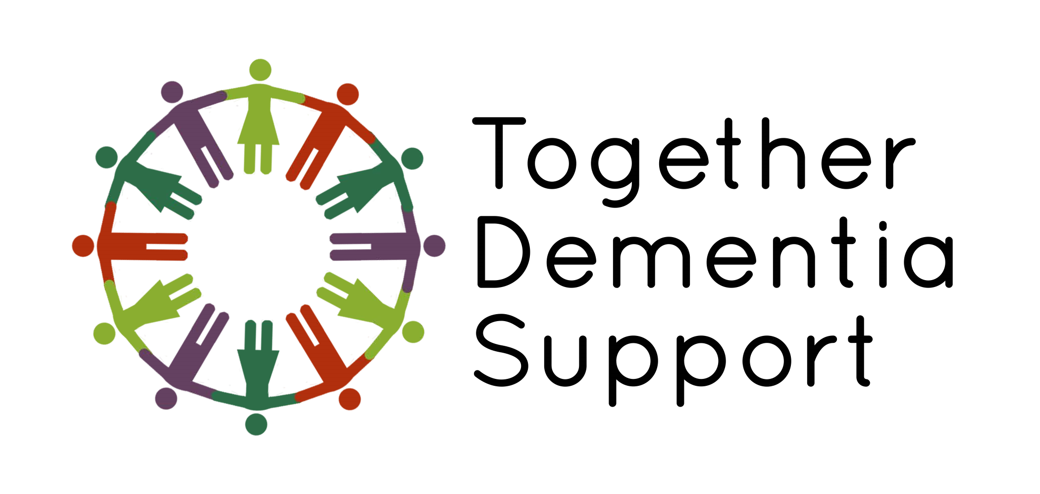

Together Dementia Support

Fundraising Pack

A guide to how you can raise
Money for TDS

What am I going to do?
What are your best ideas? It doesn’t have to be extreme! A bake sale, coffee morning, running, walking, climbing, a dress down day at work, quizzes, or sponsored silences are all great ideas!

Get some ideas from our Fab Fundraisers

Damian | Penny
Damian completed an epic Triathlon, and raised an astounding £2,116.25.  His donation meant we could buy some adapted bikes and a rickshaw for use both by our members and the general public. | Penny took on an immense challenge to walk the Wainwright Fells of the Lake District.  She set herself the modest target of £500, and completely left her target in the dust by raising an astounding £2,797.50!  Penny’s donation meant we could have Christmas parties in 2021, and funded trips to Blackpool and RHS Bridgewater for our groups.

When am I going to do it?
Make sure you give yourself enough time to plan but not too long that you lose your motivation…

What do I need?
Some fundraisers may need planning. You may need cakes, tables, plates, Sellotape, string, balloons, prizes etc., or if you’re shaving your head, just you! The list is endless. Also consider any hazards of risks in doing this activity that you need to address.

How can I advertise my event & raise awareness?
First of all, tell all your family and friends! Tell your school or your work. Tell the papers! Advertise on Facebook, Instagram and Twitter! Send your information to us and we can support you on our social media pages. Use our official TDS fundraising hashtag #TDSFundraiser

How will I collect the money?
Contact us to set up a fundraising page for your event, with your photos and message included. If you don’t want your own page, you can always ask people to give using the link here: www.togetherdementiasupport.org/donate or collect cash.

Do I need a risk assessment?
Some fund raisers may need a risk assessment. Ask us for advice if you are holding a public event by e-mailing admin@togetherdementiasupport.org. We can provide you with a Risk Assessment template to help your event be a safe and successful one.

Can I help raise more by asking people to use Gift Aid?
As we are a charity, if people pay tax, they can use Gift Aid. We can then claim an extra 25p on every £1 you raise. Fantastic!

I need some advice about my event. Who can I speak to?
When you decide on your event, let us know!! We are here to support you throughout your fundraising adventure. Send an email to admin@togetherdementiasupport.org and one of our team will be able to support you.

Where do I send the money I have raised?
Firstly …THANK YOU! Your support is invaluable to our members and carers.

You can send your fundraising money to the charity by:

Bank Transfer (BACS)
Account name: Together Dementia Support
Account no: 00025705
Sort code: 40-52-40

Cheque
Please make cheques payable to: Together Dementia Support and post them to our offices: Kath Locke Centre, 123 Moss Lane East, Manchester, M15 5DD.

Cash
If you have collected cash please make an appointment with our Business Support staff to come to the Kath Locke Centre to pay the money in. We’ll make sure we have a member of staff available to count it with you and issue a receipt.

Please call 0161 226 7186 or email admin@togetherdementiasupport.org to arrange this.

